Course Title: Social Immersive Learning
Course Code: 24UC0021
Name: L.Ishitha
Roll No: 2420030041
Section: 10

Title of the Event:
Dandiya Night Celebration

Organized by:
SAC, KLH University

Dates:
27th September, 2025

Event Summary:
The Dandiya Night celebration was organized in the college lobby area to mark the festive spirit of Navratri. The event aimed to promote cultural harmony, joy, and student engagement through traditional dance and music. Students dressed in vibrant ethnic attire participated enthusiastically, creating a lively and colourful atmosphere. The event included energetic Dandiya and Garba performances, followed by open dance sessions where students, faculty, and staff joined together in celebration. The evening was filled with rhythm, colour, and togetherness, spreading happiness and cultural pride throughout the campus.

Key Highlights:
• The event featured a beautifully decorated lobby with festive lights and cultural décor.
• Traditional Gujarati and Bollywood music added to the lively environment.
• A Dandiya competition was organized, and the best performers were awarded prizes.
• Participation from both students and faculty made the event inclusive and memorable.
• Refreshments and photo sessions added fun and excitement, making the night a joyous celebration of culture and community spirit.

My Participation:
As a participant, I actively took part in the Dandiya rounds and contributed to maintaining the festive energy throughout the evening. The event allowed me to interact with peers, appreciate Indian traditions, and enjoy the spirit of teamwork and celebration. It was a refreshing break from academics and strengthened the sense of unity among students. Participating in this cultural event also helped me embrace diversity and experience the joy of collective celebration.

Event Photographs:
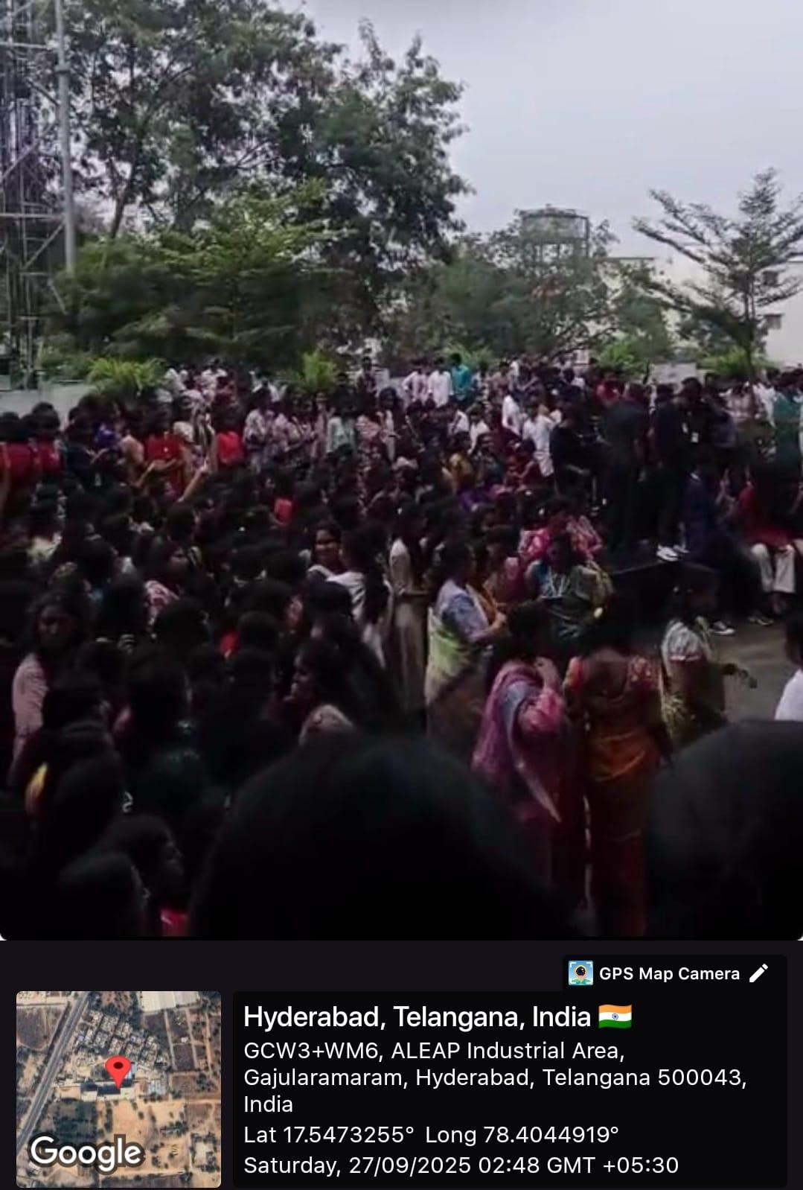

Conclusion:
The Dandiya Night was a grand success, blending tradition with youthful enthusiasm. It created lasting memories and fostered cultural appreciation within the student community. The event truly reflected the joy and unity that festivals bring to campus life.

Acknowledgment:
Special thanks to the Student Activity Centre (SAC) and KLH University for organizing such a vibrant and memorable event. Their efforts in promoting cultural engagement and providing students with opportunities to celebrate traditions are truly commendable.

